Entities and Services for a Microservice Parking Garage Management App
When designing a microservice architecture for a parking garage management application, it's essential to identify the key entities and services that will facilitate the functionality of the app. Below are suggested entities and services:
Entities
- **User **
  - Attributes:
    - User ID
    - Name
    - Email
    - Phone Number
    - Role (e.g., Admin, Customer)
  - Description: Represents individuals who use the parking service, either as customers or administrators.
- Parking Space
  - Attributes:
    - Space ID
    - Location (e.g., latitude, longitude)
    - Size (e.g., compact, standard, oversized)
    - Status (e.g., available, occupied, reserved)
  - Description: Represents individual parking spaces within the garage.
- Reservation
  - Attributes:
    - Reservation ID
    - User ID (foreign key)
    - Space ID (foreign key)
    - Start Time
    - End Time
    - Status (e.g., active, completed, canceled)
  - Description: Represents a booking made by a user for a specific parking space.
- Payment
  - Attributes:
    - Payment ID
    - User ID (foreign key)
    - Reservation ID (foreign key)
    - Amount
    - Payment Method (e.g., credit card, PayPal)
    - Status (e.g., pending, completed, failed)
  - Description: Represents the payment transactions associated with reservations.
- Garage
  - Attributes:
    - Garage ID
    - Name
    - Location
    - Total Spaces
    - Available Spaces
  - Description: Represents the parking garage itself, including its details and capacity.
- Admin
  - Attributes:
    - Admin ID
    - Name
    - Email
    - Role
  - Description: Represents administrative users who manage the parking garage operations.
Services
- User Service
  - Responsibilities:
    - Manage user registration and authentication.
    - Handle user profile updates.
    - Provide user role management.
- Parking Space Service
  - Responsibilities:
    - Manage parking space availability and status.
    - Provide search functionality for available spaces.
    - Handle space reservations.
- Reservation Service
  - Responsibilities:
    - Create, update, and cancel reservations.
    - Manage reservation statuses.
    - Notify users of reservation confirmations or changes.
- Payment Service
  - Responsibilities:
    - Process payments for reservations.
    - Handle payment status updates.
    - Integrate with third-party payment gateways.
- Garage Management Service
  - Responsibilities:
    - Manage garage details and statistics.
    - Monitor overall space availability.
    - Generate reports on usage and revenue.
- Notification Service
  - Responsibilities:
    - Send notifications to users regarding reservations, payments, and updates.
    - Manage email and SMS notifications.
- Analytics Service
  - Responsibilities:
    - Collect and analyze data on parking usage.
    - Provide insights and reports for decision-making.
    - Monitor trends in reservations and payments.
- Feedback Service (maybe also Customer Support Service)
  - Responsibilities:
    - Collects user feedback and ratings for the parking services.

Tech Spec Details

Parking Space Service:

- Represents a parking space with attributes such as:
  - id: Unique identifier for the parking space.
  - location: The geographical location of the parking space.
  - size: Size of the parking space (e.g., compact, standard, oversized).
  - availability: Boolean indicating if the space is available.
  - pricePerHour: Cost to rent the space per hour.

Notification Management Application:

Certainly! Structuring a Spring Boot notification management app for handling notifications, messages, and alerts in a microservice architecture involves several key components and design principles. Below is a comprehensive overview of how to approach this.

1. High-Level Architecture
- Microservices: Each service should be independent and responsible for specific functionalities, such as sending notifications, managing user preferences, and storing notifications.
- Communication: Use lightweight communication protocols like REST APIs or messaging queues (e.g., Kafka) for inter-service communication.
- Data Storage: Utilize a fast and scalable data store like Redis for real-time notifications and a persistent store (like Cassandra or PostgreSQL) for historical data.

2. Core Components
- Notification Service:
  - Responsible for creating, sending, and managing notifications.
  - Exposes REST APIs for other services to send notifications.
- User Preferences Service:
  - Manages user notification preferences (e.g., types of notifications, delivery methods).
  - Allows users to subscribe/unsubscribe from notifications.
- Notification Store:
  - A database (e.g., Redis) for storing active notifications.
  - A persistent database (e.g., Cassandra) for analytics and historical data.
- Frontend Integration:
  - Use Server-Sent Events (SSE) or WebSockets for real-time updates to the user interface.
  - Implement a notification center in the UI to display notifications.

3. Key Classes and Their Responsibilities
- NotificationController:
  - Handles incoming requests to send notifications.
  - Exposes endpoints for other services to interact with the notification system.
- NotificationService:
  - Contains business logic for creating and sending notifications.
  - Interacts with the NotificationRepository to store notifications.
- User PreferencesController:
  - Manages user preferences for notifications.
  - Allows users to update their notification settings.
- User PreferencesService:
  - Contains logic for managing user preferences.
  - Interacts with the UserPreferencesRepository.
- NotificationRepository:
  - Interface for interacting with the notification data store (e.g., Redis).
- User PreferencesRepository:
  - Interface for managing user preferences in the database.

High-level Design for Notification Flows

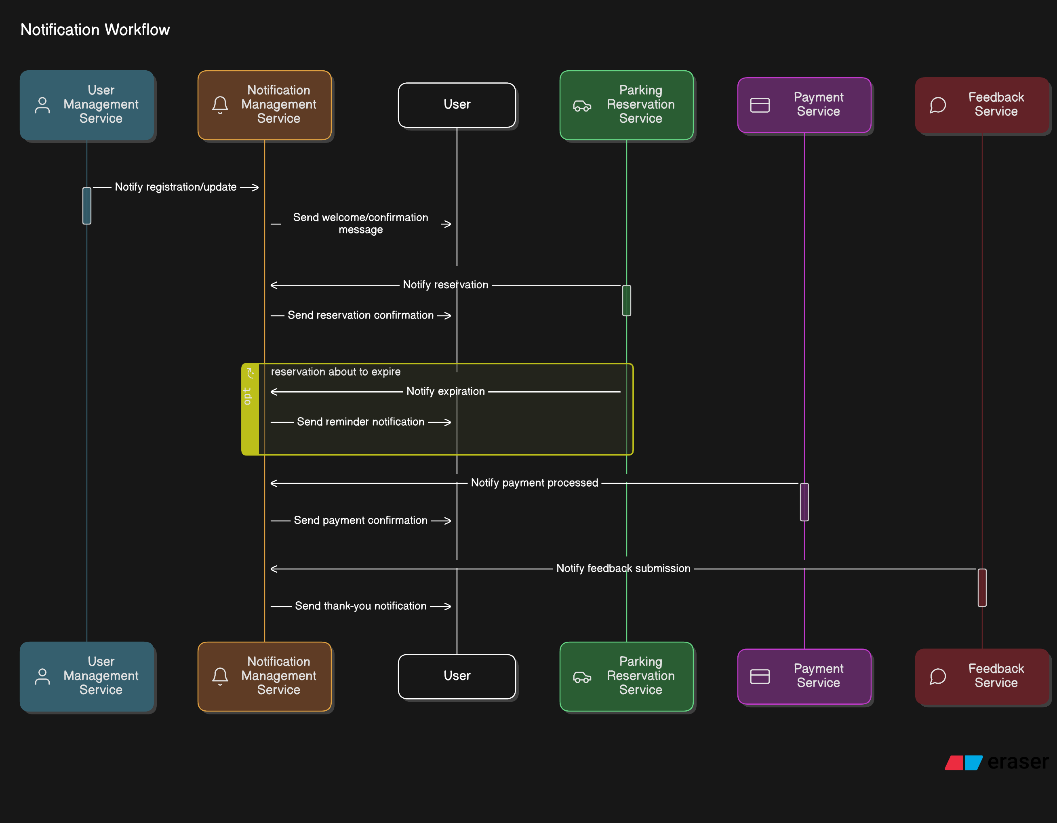

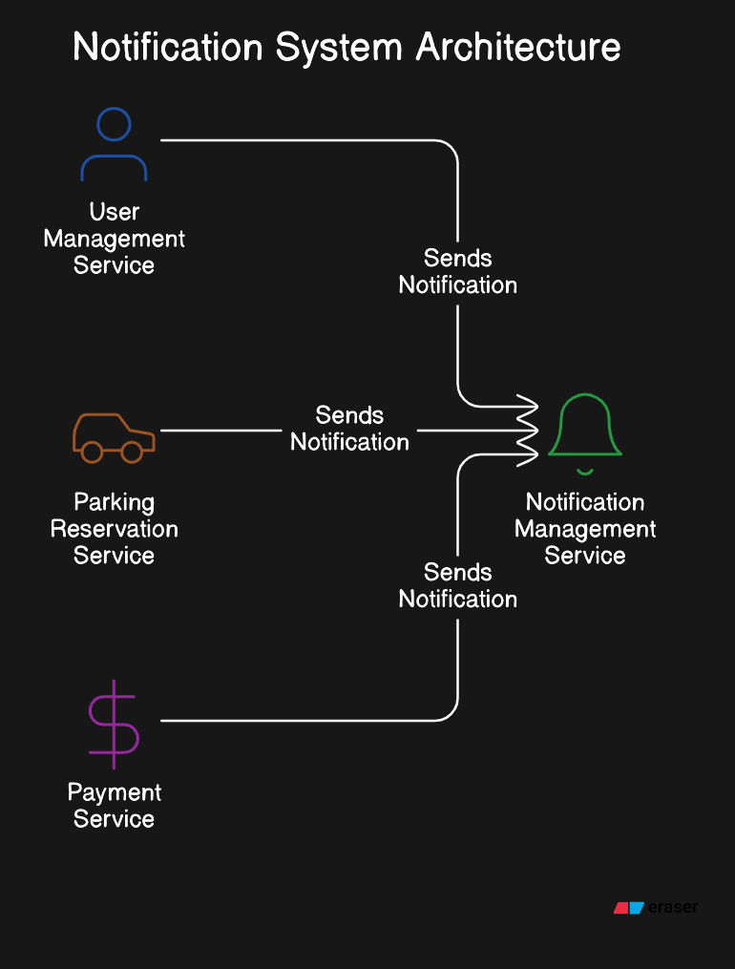

In a microservices architecture, especially one involving a Notification Management Service, the concepts of producers and consumers are essential for managing communication between services. Here’s a breakdown of whether you need a producer and consumer for each service interacting with the Notification Management Service.
Key Concepts
- Producer: A service that generates messages or events and sends them to a message broker or queue.
- Consumer: A service that receives messages from a message broker or queue and processes them.

Recommended Architecture
Centralized Notification Management Service:
Producers: Each service (User Management, Parking Reservation, Payment, etc.) can act as a producer that sends messages to the Notification Management Service.

Consumer: The Notification Management Service acts as a single consumer that processes incoming messages and sends notifications to users via email, SMS, or in-app notifications.

High-level Design for Payment Flows
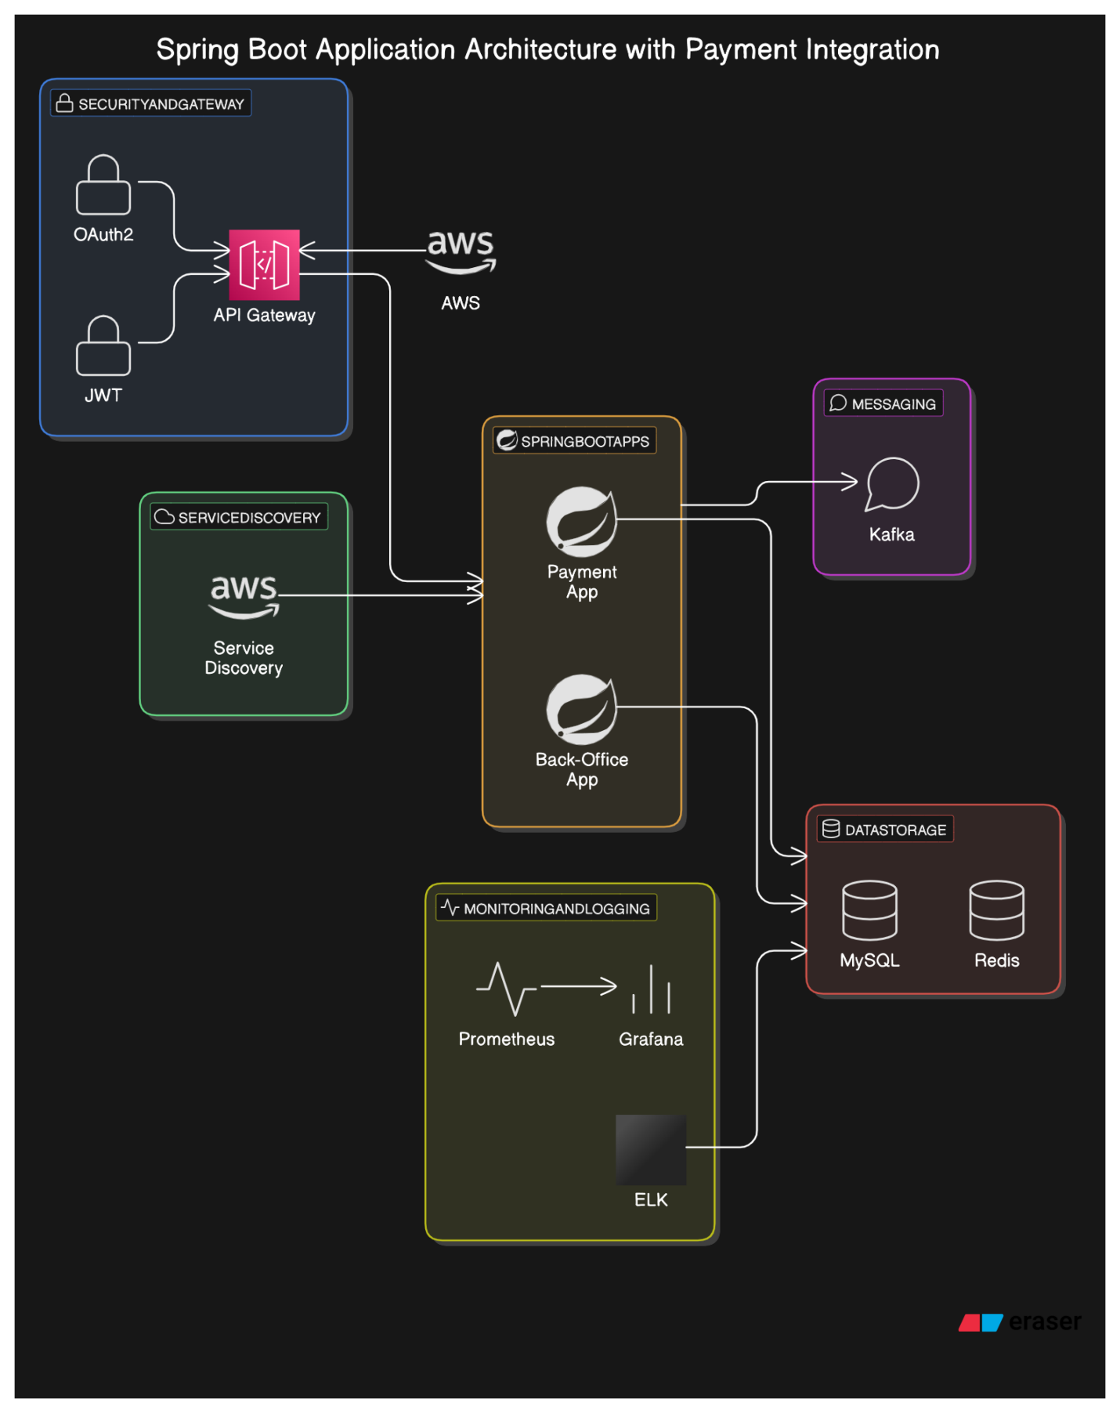

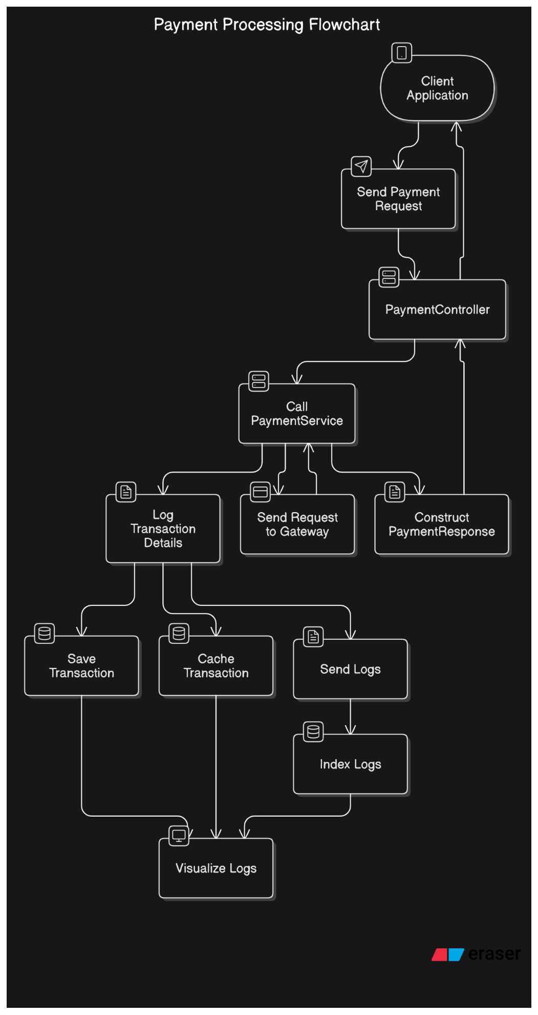

Replication for DB/Storage of the application:

Choosing the right database replication strategy (master-slave, master-master, etc.) is crucial for ensuring data consistency, availability, and performance. Here’s a breakdown of how to approach this decision based on the services:

Understanding Master-Slave Replication
In a master-slave (or primary-replica) database setup:
- Master (Primary): This instance handles all write operations (inserts, updates, deletes). It is the authoritative source of data.
- Slave (Replica): This instance replicates data from the master and can handle read operations. It is typically used to offload read traffic from the master, improving performance and scalability.
Considerations for Choosing Master-Slave Instances
- Read vs. Write Operations:
  - High Read Demand: If a service has a high volume of read operations compared to write operations, it may benefit from a slave instance. For example, the Analytics & Reporting service may require frequent reads of data for generating reports, making it a good candidate for using a slave instance.
  - High Write Demand: Services that require frequent updates or inserts, such as User Management or Reservation Service, should primarily use the master instance to ensure data consistency.
- Data Consistency Requirements:
  - Strong Consistency: Services that require the most up-to-date data (e.g., Payment Service or Reservation Service) should interact with the master instance to avoid stale data issues.
  - Eventual Consistency: Services that can tolerate some delay in data consistency (e.g., Notification & Message Management) may use slave instances for reads, as they can handle slightly outdated information.
- Service Dependencies:
  - Inter-Service Communication: Consider how services interact with each other. If one service relies on the data from another, it may be necessary for both to read from the same instance (preferably the master) to ensure consistency.
  - Data Aggregation: Services like Analytics & Reporting may aggregate data from multiple sources. In this case, they might need to read from both master and slave instances, depending on the data freshness required.
- Scalability:
  - Load Balancing: Using slave instances can help distribute read traffic, allowing your application to scale more effectively. For example, if your Garage Management service frequently queries available parking spaces, it can benefit from read replicas.
  - Horizontal Scaling: If you anticipate significant growth, consider how many read replicas you might need and how they will be managed.
- Failover and Redundancy:
  - High Availability: In a master-slave setup, if the master fails, you may need to promote a slave to master. Ensure that your architecture includes a strategy for failover and that your application can handle such transitions gracefully.
  - Backup and Recovery: Regularly back up your master and slave instances to prevent data loss and ensure quick recovery in case of failure.
Suggested Database Replication Strategy for Each Services
Based on the services you mentioned, here’s a suggested approach:
- User Management Service: Use the master instance for both reads and writes to ensure user data is always up-to-date.
- Garage Management Service: Use the master for writes (e.g., adding or updating garage information) and consider using a slave for read operations (e.g., querying available garages).
- Parking Space Service: Similar to Garage Management, use the master for writes and a slave for reads to handle queries about available parking spaces.
- Reservation Service: Use the master instance for all operations to ensure that reservations are processed accurately and consistently.
- Payment Service: Always use the master instance to ensure that payment transactions are processed with the most current data.
- Analytics & Reporting Service: Use slave instances for read operations to offload traffic from the master and improve performance. However, ensure that the data is sufficiently fresh for reporting needs.
- Notification & Message Management: Depending on the implementation, this service can read from a slave instance if it can tolerate eventual consistency.
- Feedback (Customer Service): Use the master instance for writes (e.g., submitting feedback) and consider using a slave for reads if the feedback data does not need to be real-time.
Summary
- Master-Slave Setup: Use master instances for services with high write demands and strong consistency requirements. Use slave instances for services with high read demands and where eventual consistency is acceptable.
- Service Dependencies: Consider how services interact and ensure that data consistency is maintained where necessary.
- Scalability and Load Balancing: Use slave instances to distribute read traffic and improve scalability.
- Failover and Redundancy: Implement strategies for failover and ensure high availability.

